Glow in the Dark Lava Lamp

Subject: Chemistry  Related Subjects: Reactions | Grade Level(s):  Length of Lesson: 120 Minutes | Type: Inquiry / Design / Project  Keywords: phosphors, chemical bonds, chemical reactions

Lesson Overview
Students will gain an understanding of basic chemical reactions and chemical bonds, as well as understand the reasons why these reactions proceed. Moreover, students will use explore the reasons as to why these reactions are important, and apply them to the real world.

Lesson Focus
What is the central question or phenomenon being investigated? What problem are they trying to solve?

Lesson Objective(s) | - The student will learn about basic chemical bonds and reactions

Lesson Timing

Time [min] | Description
5 | Introduce the Lesson  - End Goal  - Primer Questions  - Key Vocab Words
1 | Role Models in STEM
Engineering Method
5 | Real World Example
5 | Hypothesis & Prediction
5 | Brainstorm & Design
20 | Build & Create
10 | Test & Record
5 | Assess & Evaluate
5 | How to improve?
10 | Lesson Cleanup

Materials | - 30 empty plastic bottles  - 30 non-toxic glow sticks  - 30 cups of baby oil or vegetable oil  - 30 Alka-Seltzer tablets
Instructor Prep | - Make sure to attain thick/tested glow sticks or those that will empty into the bottle.
Related Resources | - List related lessons/ppts etc available from USC or outside, trusted orgs

Lesson Plan

Introduction
- What are some chemical reactions that happen everyday?
  - Plant photosynthesis
  - Cooking
  - Cleaning products
  - Rust
  - Moving with our muscles
- How do we use chemical reactions in our everyday life?
  - Cleaning
  - Fire for cooking
  - Car or transportation
- Why do you think water and oil can’t mix?
  - They are made of different chemical bonds
  - Oil is less dense than water
  - Water molecules are strongly attracted to each other, so will not break to let room for oil molecules

Procedure
- Put a small amount of water (about an inch or two) in the bottom of the plastic bottle or cup.
- Add some fluorescent paint or break open a glow stick and add it to the water and mix.
- Using the funnel pour the baby oil into the bottle, filling almost to the top.
- You will see that the water and oil settle into two layers, with the water at the bottom.
- Break up the Alka-Seltzer tablets into smaller piece
- Add some pieces of the Alka-Seltzer tablet to the bottle to start off your lava lamp.
- Once the bubbles stop rising you can add more tablets to keep the lava lamp going.

Wrap-up
The purpose of the survey is to let us know your opinions about today’s project. Remember there are no right or wrong answers.

 |  | Strongly Disagree | Disagree | Undecided | Agree | Strongly Agree
1 | The project increased my interest in science
2 | After this project, I am more confident in doing science

3. What does a chemist do?

4. Why doesn’t the water and oil mix together?

5. What caused the oil in the lava lamp to bubble and why?

Lesson Background for Teachers

Suggested Real-World STEM Connections

Real World Example
- Cleaning Metals
- Antacids
- Cooking (for uses such as vinegar)

Hypothesis & Prediction
- Will shaking the bottle as hard as possible allow the oil and water to combine?
- Can we make the lava lamp bubble for longer?

Brainstorm & Design
- What happens when adding 1 or multiple Alka-Seltzer tablets?
- Will different ratios of glow sticks, water, and oil affect the experiment?

Build & Create
- Students will determine how they want their lava lamp to look (more color, bubbles, oil, or water) and experiment with different ratios to create their perfect lava lamp.

Test & Record
- Students will observe how different amounts of ingredients affect the lava lamp

Assess & Evaluate
- Students can assess the success of their ingredient recipes by viewing which items shoots up the farthest as well as how quickly the reaction proceeds.

How to Improve?
What other materials could you use?

Role Model in STEM

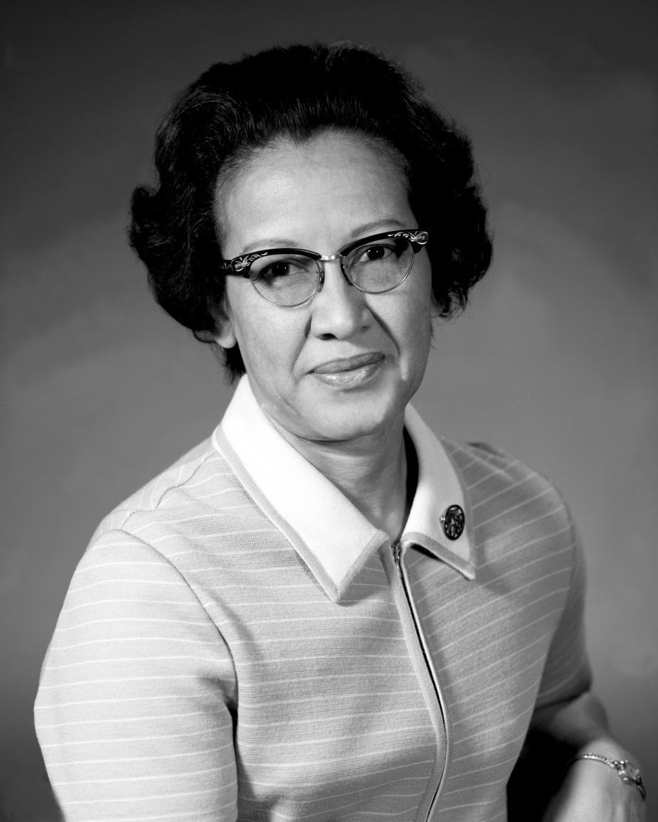
Name: Katherine Johnson
Years: 1918 - present
Quick Facts
- She is a physicist and mathematician
- The new movie Hidden Figures is based off her
- She was awarded Presidential Medal of Freedom
- She made contributions to the United States’ aeronautics and space programs with digital electronic computers at NASA
- Her calculations helped synch Project Apollo’s Lunar Lander with the moon-orbiting Command and Service Module.

Source(s):
- https://en.wikipedia.org/wiki/Katherine_Johnson
- https://www.nasa.gov/content/katherine-johnson-biography

Lesson Variations and Options
Include descriptions of alternative methods or ways to present things.

Explanation
The oil and water stay separated because they have different chemical bonds which do not mix. The Alka-Seltzer creates a chemical reaction between an acid and base, which causes carbon dioxide to bubble up through the oil.

Key Concepts and Vocabulary
- Chemical reaction
  - A process that involves rearrangement of the molecular or ionic structure of a substance, as opposed to a change in physical form
- Chemical bond
  - Attraction between atoms to keep molecules together
- Solute
  - The minor component of a solution i.e. Sugar in coffee.
- Molecules
  - A structure consisting of a combination of atoms. Are the smallest structure that occurs in a chemical reactions
- Atoms
  - Small fundamental structured particles that consist of neutrons, protons, and electrons

Safety Notes
- Safety instruction

